# **If-Expressions**

Students build on their knowledge of the image-scatter-plot function, motivating the need for if-expressions in their programming toolkit. This drives deeper insight into subgroups within a population, and motivates the need for more advanced analysis.

| **Prerequisites** | [Defining Functions](https://bootstrapworld.org/materials/spring2021/en-us/courses/data-science/lessons/ds-defining-functions/index.shtml) |
| --- | --- |
| **Relevant StandardsK12CSCSTANGSS** | *Next-Gen Science Standards*  **HS-SEP4-5**  Evaluate the impact of new data on a working explanation and/or model of a proposed process or system. |
| **Lesson Goals** | Students will be able to…​   * use if-then-else expressions in Pyret * explain the behavior of a (specific) higher order function |
| **Student-facing Lesson Goals** | * Let’s explore functions that behave differently based on the input. |
| **Materials** | * [Lesson Slides](https://docs.google.com/presentation/d/1l07Bp3edL3jvpXfs_K9ks69lcLpw4MOKiG5go1v09K4/) * [Custom Animal Images Starter File](https://code.pyret.org/editor#share=1DeSbekzW7SMh4fnIN1_aVGYZu5EtRvRZ) * [Animals Starter File](https://code.pyret.org/editor#share=1ZupMVPWvVUOM0HCWyA7cRBghSLKxPWv1) * [The Mood Generator Starter File](https://code.pyret.org/editor#share=1ymyvlI7RTtq8lHh4VH3x1N3WlcZB650j) * [Mood Generator (Page 37)](https://bootstrapworld.org/materials/spring2021/en-us/courses/data-science/lessons/ds-if-expressions/pages/MoodGenerator-intro.html) * [Word Problem: species-color (Page 38)](https://bootstrapworld.org/materials/spring2021/en-us/courses/data-science/lessons/ds-if-expressions/pages/species-color.html) |
| **Preparation** | * Make sure all materials have been gathered * Decide how students will be grouped in pairs * Computer for each student (or pair), with access to the internet * [Student workbook](https://bootstrapworld.org/materials/spring2021/en-us/courses/data-science//workbook/workbook.pdf), and something to write with * All students should log into [CPO](https://code.pyret.org/) and open the "Animals Starter File" they saved from the prior lesson. If they don’t have the file, they can [open a new one](https://code.pyret.org/editor#share=1ZupMVPWvVUOM0HCWyA7cRBghSLKxPWv1) |
| **Supplemental Resources** |  |
| **Language Table** | | Types | Functions | Values | | --- | --- | --- | | **Number** | num-sqrt, num-sqr | 4, -1.2, 2/3 | | **String** | string-repeat, string-contains | "hello", "91" | | **Boolean** | ==, <, <=, >=, string-equal | true, false | | **Image** | triangle, circle, star, rectangle, ellipse, square, text, overlay, bar-chart, pie-chart, bar-chart-summarized, pie-chart-summarized | 🔵🔺🔶 | | **Table** | count, .row-n, .order-by, .filter, .build-column |  | |

## Warmup

Age v. Weeks Scatterplot

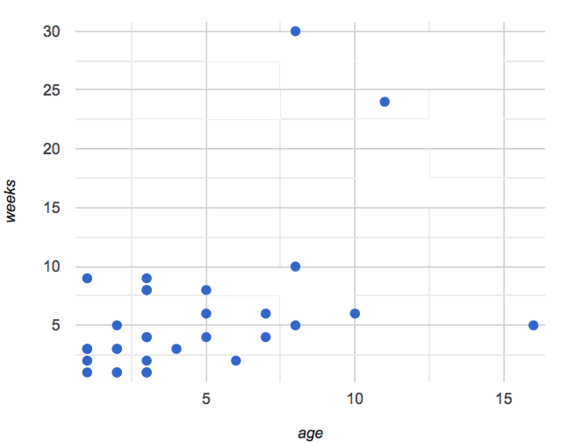

1. Show students [this code](https://code.pyret.org/editor#share=1DeSbekzW7SMh4fnIN1_aVGYZu5EtRvRZ), which uses image-url and scale to generate icons of animals.
2. What do they Notice? What do they Wonder? How might this scatterplot change our analysis?
3. Have students make a scatter plot of animals, using age as the x-axis values and weeks as the y-axis.

(For now, the scatter plot is *purely* to give students practice with contracts and displays. They are **not** expected to know much about scatter plots at this point.)

## If-Expressions

## 20 minutes

### *Overview*

Students explore a program that makes use of an *if-expression*, develop their own understanding, and modify it.

### *Launch*

So far, all of the functions we know how to write have had a *single rule*. The rule for gt was to take a number and make a solid, green triangle of that size. The rule for bc was to take a number and make a solid, blue circle of that size. The rule for nametag was to take a row and make an image of the animal’s name in purple letters.

What if we want to write functions that apply different rules, depending on the input? For example, what if we want to change the color of the nametag depending on the species of the animal?

### *Investigate*

* Open the [Mood Generator starter file](https://code.pyret.org/editor#share=1ymyvlI7RTtq8lHh4VH3x1N3WlcZB650j).
* Complete [Mood Generator (Page 37)](https://bootstrapworld.org/materials/spring2021/en-us/courses/data-science/lessons/ds-if-expressions/pages/MoodGenerator-intro.html) in your student workbooks.

### *Synthesize*

Have the class share their own explanations for how if-expressions work.

Pyret allows us to write if-expressions, which contain:

1. the keyword **if**, followed by a *condition*.
2. a colon (:), followed by a rule for what the function should do if the condition is true
3. an **else**:, followed by a rule for what to do if the condition is false

We can chain them together to create multiple rules, with the last **else**: being our fallback in case every other condition is false.

## Better Image Scatter Plots

## 20 minutes

### *Overview*

Students discover how "dot appearance" can be used to show more data in a scatterplot, and why that would be valuable.

### *Launch*

Suppose we want to make a scatter plot for the Animals Dataset, but with dots taking different colors depending on the species. This would make it possible to see if certain species are "clustered" in different parts of the plot.

### *Investigate*

Have students open [Word Problem: species-color (Page 38)](https://bootstrapworld.org/materials/spring2021/en-us/courses/data-science/lessons/ds-if-expressions/pages/species-color.html). Make sure they all write the Contract and Purpose Statement *first* , and check in with their partner *and* the teacher before proceeding.

Once they’ve got the Contract and Purpose Statement, have them come up with **examples**: for *each species*. Once again, have them check with a partner *and* the teacher before finishing the page.

Once another student *and* the teacher has checked their work, have them type this function into their animals starter files, and use it to make an image-scatter-plot using age as the x-axis and weeks as the y-axis.

### *Synthesize*

Age v. Weeks Scatterplot

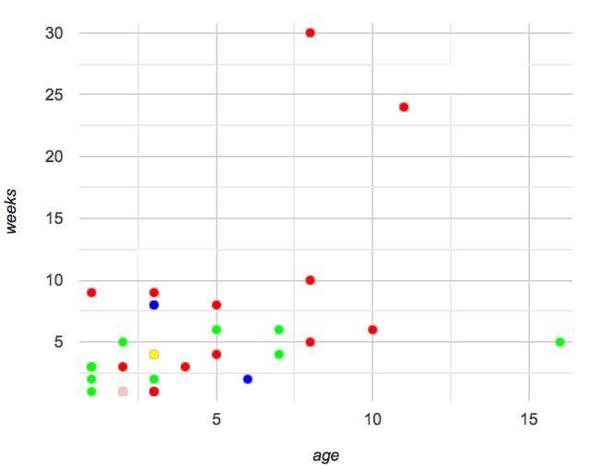

1. What do you Notice about this scatter plot?
2. What do you Wonder?

What does this new visualization tell us about the relationship between age and weeks? What other analysis would be helpful here?

## Closing

Make sure to direct the conversation *back to Data Science!* Does this scatter plot make us think we should be analyzing animals separately? What other scatter plots might this be useful for?

*This scatterplot makes it clear that we may want to analyze each species separately, rather than grouping them all together!* In the next lesson, students will learn how to do just that.